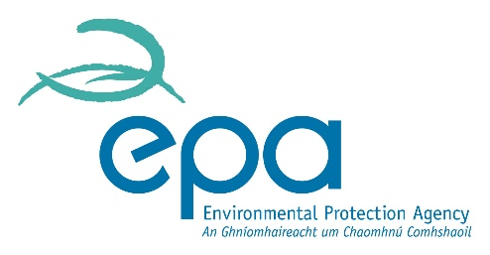 

***Environmental Law Enforcement: Emerging Challenges 2023***

**16 November 2023**

**Application Form for PhD Students**

**Name:**

**Institutional Affiliation:**

***(Note: In order to be eligible for consideration, a student must be currently registered in a PhD programme at a Higher Education Institution in Ireland or in Northern Ireland).***

**Address:**

**Email address:**

**Contact phone number:**

**Year of PhD programme (i.e. Year 2, Year 3 etc.):**

***(Note:*** ***Students must have completed at least the first year of the PhD programme at their Higher Education Institution in order to be eligible for consideration – or at least two years if registered part time).***

**Please indicate whether registration is full time or part time:**

**Funding body/bodies supporting the student’s PhD studies to date (if applicable):**

***(Note: If more than one funding body, please specify, including the relevant year(s) of funding for each distinct funding body).***

**Title of PhD research project:**

**Research supervisor(s):**

**Research supervisor(s) email address(es):**

**Applicant’s Electronic Signature:**

**Date:**

**ABSTRACT (500 words max)**

***The Abstract should set out clearly the particular issue / research question that you propose to speak on at the conference. This should also be reflected clearly in the title of your Abstract. The title does not count towards the word limit.***