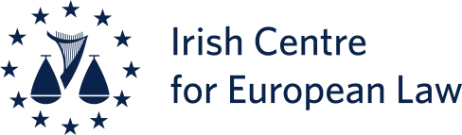

Windsor Framework, Article 2:

where are we now after the Court of Appeal’s decision in the Dillon (Legacy Act) case?

Date: 24th October 2024
Venue: Moot Court Room, QUB School of Law, Belfast

12.30 | Registration and Sandwich Lunch
13.00 – 13.15 | Welcome and Introduction Robert McTernaghan BL

Chair: Christopher McCrudden

Programme

13.15 to 14.15 | Session 1: Using Article 2 in domestic litigation: the basics after Dillon
13.15 – 13.35  13.35 – 13.55  13.55- 14.15 | Dr. Lisa Whitten (QUB)  Anurag Deb (QUB)  Q & As  Issues to be considered:  - status and effect of section 7A of the European Union (Withdrawal) Act 2018  - overall justiciability of Article 2 Windsor Framework  - effect of Article 4(1) of the Withdrawal Agreement on the approach to be taken to the scope and application of Article 2 WF  - the ‘direct effect’ of Article 2 WF

14.15 to 15.15 | Session 2: Remedies after Dillon
14.15 - 14.35  14.35 - 14.55  14.55 – 15.15 | Professor Colin Murray (Newcastle)  Professor Eleni Frantziou (Durham)  Q & As  Issues to be considered:  - approach that will be adopted to the issue of remedies in the event that a breach of Article 2 WF is established  - in particular whether the remedy of ‘disapplication’ is mandatory where a breach of Article 2 WF has been established  - relationship between ECHR remedies and remedies under Article 2 WF
15.15 to 15.45 | Tea/coffee break
15.45 to 16.45 | Session 3: Scope of rights protected by Article 2 after Dillon
15.45 – 16.05  16.05 – 16.25  16.25 – 16.45 | Professor Tobias Lock (Maynooth)  Professor Emeritus Brice Dickson (QUB)  Q & As  Issues to be considered:  - Vienna Convention on the Law of Treaties and the interpretation of the B-GFA  - interpretation of the relevant part of the Belfast-Good Friday Agreement (‘B-GFA’), and in particular the scope of ‘civil rights’ in that context  - relationship between the ECHR, the Charter of Fundamental Rights and breaches of Article 2 WF, and in particular the issue of ‘diminution’ in that context  - scope of the CFR
16.45 to 17.15 | Questions and moderated discussion
17.15 to 17.30 | Closing comments (Advocate General Anthony Collins)  (Chair: Robert McTernaghan BL)

17.30 | Drinks reception

